GM 2e
Solutions to Select Quantitative Problems and Conceptual Questions

Chapter 10

  - The value of any asset is the PV of expected future cash flows (operating and reversion/sale).
In this case we have

This looks strange because the sale price is a function of the current value, which is what you are trying to find. You can solve this for V as follows (use the annuity keys to solve for the PV 0f 150 for 10yrs @15%)

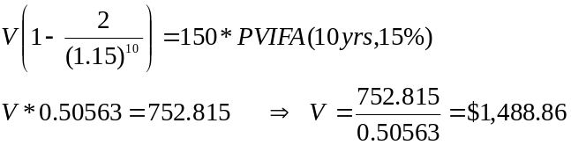

What (at least undergrad) students you may have tried to do

Given the constant, perpetual NOI the tendency is to calculate

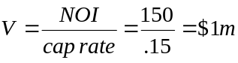

which means that the expected sale price in 10 years in $2m.

This does not work though. Why? If you were to purchase a property today that has expected NOI of $150,000 per year, an expected sale price of $2m in year 10 then assuming a 15% discount rate you should be willing to

which does not equal $1m.

Essentially what is going on is you cannot use the perpetuity formula (NOI/k) because the discount rate is not assumed to be constant forever; or the ratio of property value to current income (i.e. cap rate) is expected to change.

